**Assignment 8**

**Initialize a new Git repository in a directory of your choice. Add a simple text file to the repository and make the first commit.**

Step 1: Create a new Directory and sample text file inside the directory.

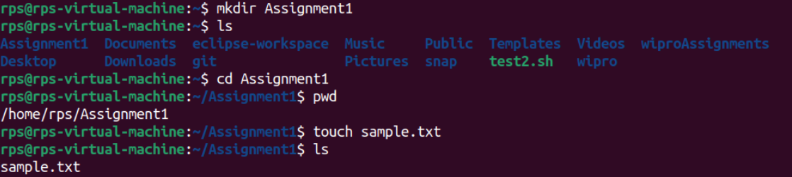

Step 2: Clone the git repository to the directory.

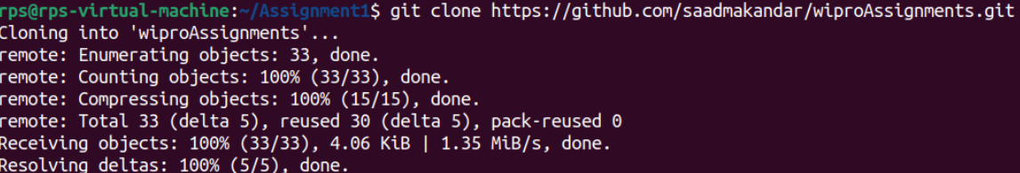

Step 3: Make the first commit after adding files to the staging area.

